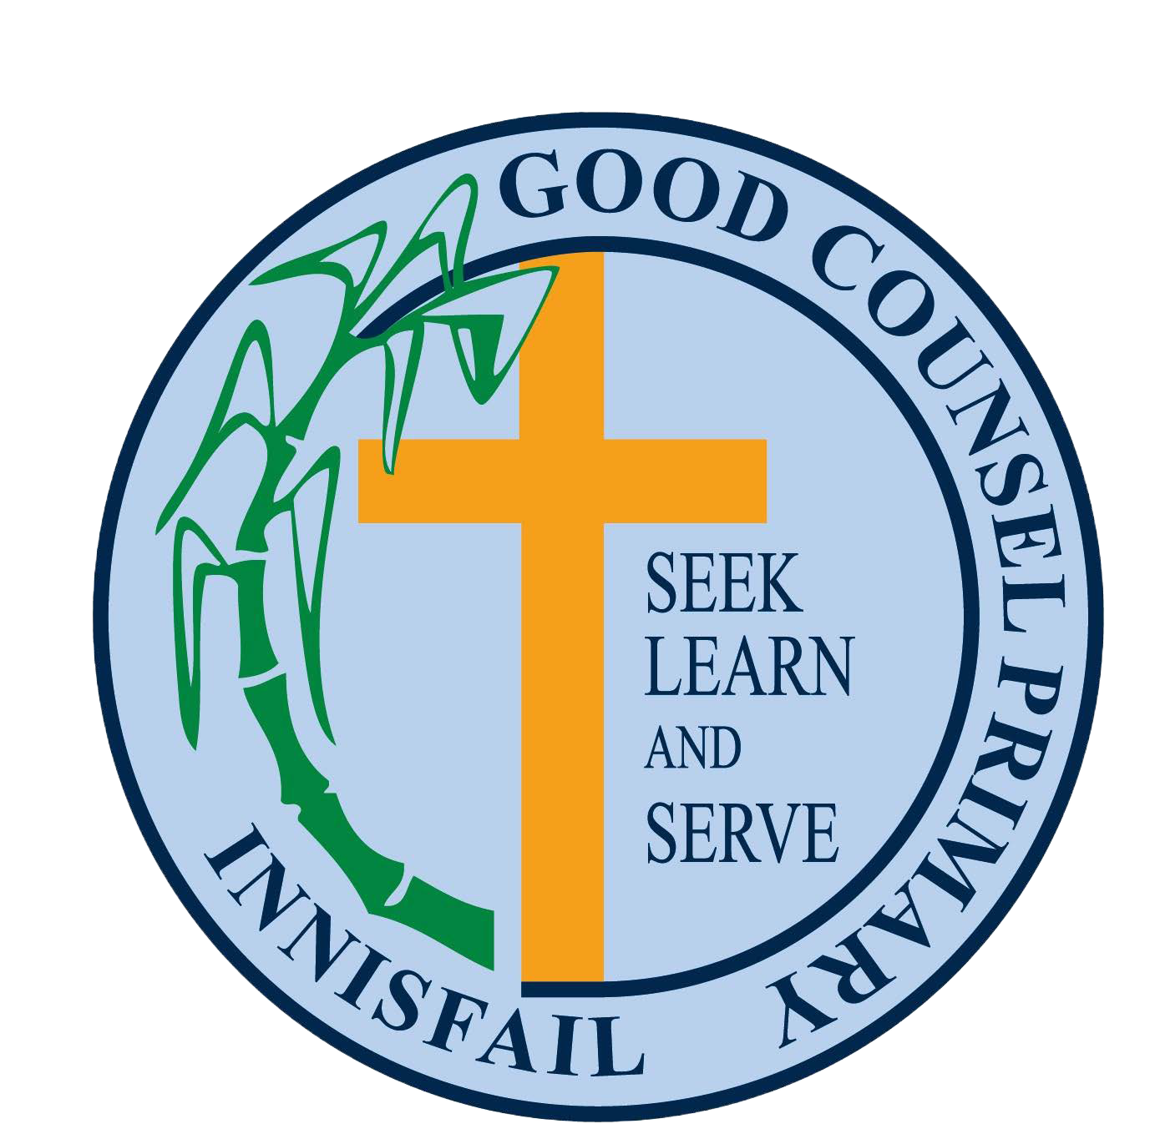

Good Counsel Primary School - SunSmart Policy Statement

# Rationale

Queensland has the highest rate of skin cancer in the world. Of all new cancers diagnosed in Australia each year, 80 per cent are skin cancers. Research indicates childhood sun exposure is an important contributing factor to the development of skin cancer in later life. Given students are at school during peak ultraviolet radiation (UVR) times throughout the day, between 10am and 3pm, schools play a major role in both minimising a student’s UVR exposure and providing an environment where policies and procedures can positively influence student behaviour.

Skin damage, including skin cancer, is the result of cumulative exposure to the sun. Research shows severe sunburn contributes to skin cancer and other forms of skin damage such as sunspots, blemishes and premature ageing. Most skin damage and skin cancer is therefore preventable.

Ultraviolet radiation (UVR) levels are highest during the hours children are at school. As children will spend a portion of their day outdoors, we are committed to protecting them from the harmful effects of the sun. With this in mind Good Counsel Primary School realises the need to protect

children’s skin and educate them about SunSmart behaviour, thus reducing the risk of skin damage from exposure to the sun.

# Aims

The policy aims to:

* Provide ongoing education that promotes personal responsibility for skin cancer prevention and early detection;
* Provide environments that support SunSmart practices; and
* Create an awareness of the need to reschedule outdoor activities to support SunSmart practices.

# Our Commitment

Good Counsel Primary School will:

* Inform parents of the SunSmart policy when they enrol their child.
* Include the SunSmart policy statement in the school prospectus.
* Increase the amount of shade in the school grounds, where possible, by building shelters and planting trees.
* Encourage all teachers and staff to act as positive role models for children in all aspects of SunSmart behaviour.
* Seek ongoing support from parents and the school community for the SunSmart policy and its implementation, through newsletters and parent meetings.
* Ensure all students and staff wear hats that protect the face, neck and ears and SPF 30+ broad-spectrum, water-resistant sunscreen when involved in outdoor activities.
* Encourage students without adequate sun protection to use shaded or covered areas at recess and lunch times.
* Ensure the school dress code to conforms with The Cancer Council Queensland SunSmart clothing guidelines.

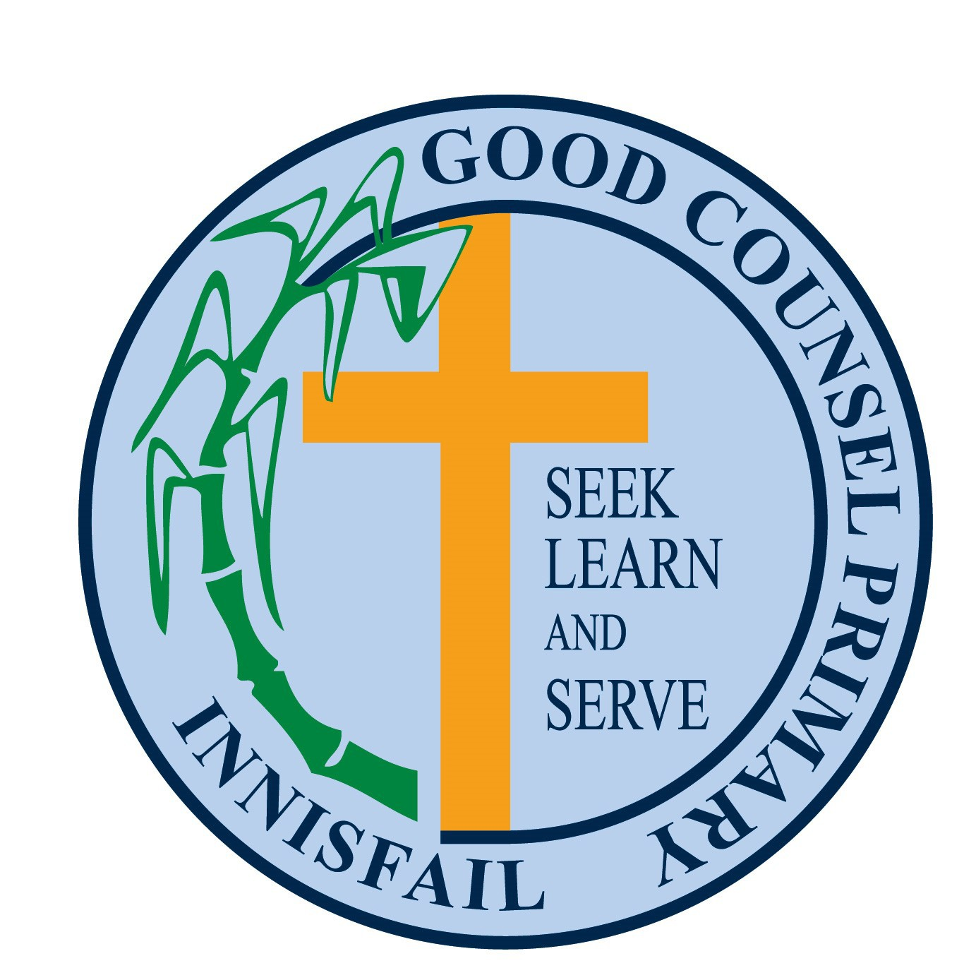

* Ensure adequate shade is provided at sporting carnivals and other outdoor events.
* Ensure SPF 30+ broad-spectrum, water-resistant sunscreen is included in the school sports kit.
* Ensure parents are notified of details of any school provided sunscreen, in the event that the student may be allergic to the sunscreen being used.
* Review the SunSmart policy biennial.

# Parent and carer’s commitment

Parents/carers will:

* Provide a SunSmart hat for their child to be [worn](https://www.sunsmart.com.au/downloads/resources/info-sheets/top-tips-school-uniform.pdf) when required.
* Purchase a wide brimmed hat.
* Ensure their child’s clothing provides adequate protection from UVR, in line with Cancer Council guidelines.
* In the event that your child has an allergic reaction to sunscreen pleasae notify the school WPH&S Officer.

# Student commitment

Students will:

* Be aware of the school’s SunSmart policy;
* Take responsibility for their own health and safety by being SunSmart;
* Comply with SunSmart rules and guidelines.nglasses;
* When practical use shaded or covered areas when outdoors;
* Act as positive role models for other students in all aspects of SunSmart behaviour;

Considered and accepted by the Principal

Name: Liam Kenny Date:

Considered and accepted by Parents and Friends Committee

Name: Tania Spagnolo Date: